VIRGINIA VETERANS SERVICES FOUNDATION

Inter-Agency Relations between the Veterans Services Foundation

and the Department of Veterans Services including the

Board of Veterans Services and the

Joint Leadership Council of Veterans Service Organizations Policy

Short Title – Inter-Agency Relations

F1.1 Purpose
The purpose of this policy is to establish guidelines and policy for coordination between the Virginia Veterans Services Foundation (VSF) and the Virginia Department of Veterans Services (DVS) including the Board of Veterans Services (BVS) and the Joint Leadership Council of Veterans Service Organizations (JLC).

F1.2 Application
The Chair of the VSF Board of Trustees (the trustees) with advice from the VSF Executive Director, DVS Commissioner, and Chairmen of BVS and JLC or their designees shall be responsible for the application of this policy.

F1.3 Interpretation
The VSF Trustees Chair (Board Chair) or his/her designee, in consultation with the Secretary of Veterans and Defense Affairs shall be responsible for the interpretation of this policy.
F1.4 References
- Virginia Code (the Code) §2.2-230 states the agencies for which the Secretary of Veterans and Defense Affairs is responsible to the Governor. The Code §2.2-2000 et seq. establishes DVS and its divisions. The Code §2.2-2452 and §2.2-2681 establishes BVS and JLC respectively as a policy board and advisory council to DVS. The Code §2.2-2715 establishes VSF as an independent agency supporting the interests of veterans and their families and contributors through the Secretary of Veterans Services and the programs and services of DVS. A chart at Appendix A displays these government activities and their relationships. The Virginia War Memorial Foundation (VWMF) Board is in Appendix A, but is under the supervision of the DVS Commissioner and is included under exceptions to this policy in section F1.9.
- Virginia Code §2.2-2001.A authorizes DVS to establish, operate, administer and maintain offices and programs related to services for veterans of the armed forces of the United States and their Virginia-domiciled spouses, orphans and dependents. The DVS Commissioner heads DVS and is supported by, and supports, the BVS, the JLC, and the VSF.
- Virginia Code §2.2-2715.B. provides for VSF to (i) administer the Veterans Services Fund (the Fund), (ii) provide funding for veterans services and programs through the Fund, and (iii) raise revenue from all sources to support the Fund.
- The Memorandum of Understanding (MOU) between VSF and DVS (see Appendix B) sets forth the relationships between the two agencies and provides the basis for this policy. VSF and DVS are mutually supporting agencies.

- Virginia Code §2.2-2715.C. specifies that the Secretary of Veterans and Defense Affairs and the Chairmen of BVS and JLC serve as ex officio voting trustees of the board of trustees of VSF.
- Virginia Code §2.2-2103 states that, “Upon request, all agencies and political subdivisions of the Commonwealth shall assist any authority, board, commission, council or other collegial body established in this title in carrying out the respective duties for which each was created.”

F1.5 Overview of VSF and DVS
- VSF is responsible for providing direct mutual support to DVS.

- Direct mutual support means VSF specifically supports DVS and is authorized to answer directly to DVS’ request for assistance. Additionally, DVS provides direct mutual support to VSF in support of both agencies’ common goal of providing services to veterans and their families, because of each agency’s: (1) assigned tasks; (2) position relative to each other; (3) common goals; and (4) inherent capabilities.

- Mutual support is a form of partnership to accomplish a common goal and means that each counterpart has a degree of authority over the other in actions that have mutual effects and that mutual costs and benefits are shared as equitably as possible. The mutual relationship exists between DVS and VSF because each agency was established to provide effective and efficient services. Each collects, uses, and preserves resources for current and future contingencies and maintains financial accountability and integrity through separate independent operations. The relationship is built on mutual respect for the different purpose or mission, authority, and responsibility of the two agencies and their common goal. The elements of that mutual support are contained in a DVS-VSF MOU and supporting Joint VSF-DVS Policies.

- In the context of the DVS and VSF relationship, the DVS Commissioner or VSF Executive Director, who receives assistance from each other’s agency or capabilities, is responsible for ensuring the supported agency understands the assistance required.

F1.6 Overview of BVS and JLC
- BVS is a policy board that advises the DVS Commissioner on veteran issues, delivery of services, plans, projects and policies and procedures. BVS also makes recommendations to DVS and VSF regarding gifts, grants and other resources from public and private entities in support of services to veterans.

- JLC is an advisory council that advises the General Assembly and the DVS Commissioner on support for veteran services and programs and addressing veteran issues (i.e., needs) not currently provided.

F1.7 Policy
- It is the policy of VSF and DVS to ensure cooperative and efficient inter-relationships between VSF, DVS, BVS, and JLC.

- VSF shall entertain only funding requests from BVS and JLC that have been reviewed and approved by DVS and the Secretary of Veterans and Defense Affairs.

F1.8 Procedures
- Detailed procedures for VSF and DVS are contained in VSF-DVS Joint Policies 11 through 14

- In most cases, the procedure for commencing interactions between DVS, BVS, JLC and VSF is for JLC to identify an unmet need. The need then would be passed to BVS for its insight and recommendations on best practices, management and performance requirements, non-profit operations and other considerations. BVS then would validate the requirement and pass its recommendation to DVS for consideration. DVS may consider internal resources or external resources, including VSF resources, to address the unmet need.

- When BVS identifies a need, it would be passed to JLC for validation. If validated, it then would be passed to DVS and the Secretary of Veterans and Defense Affairs for consideration, in consultation with BVS. DVS may consider internal resources or external resources, including VSF resources, to address the need.

- DVS needs typically should be passed to BVS for vetting and recommendations, and then passed to JLC, VSF, or another agency, as appropriate.

F1.9 Exceptions
- Exceptions to this policy shall be determined by VSF in consultation with DVS and the Secretary of Veterans and Defense Affairs. BVS, JLC and other activity(ies) involved, if any, may be consulted by DVS.

- JLC under Code of Virginia §2.2-2682.C “…may apply for funds from VSF to enable it to better carry out its objectives. JLC shall not impose unreasonable burdens or costs in connection with requests of agencies.” Applications shall be made through the DVS Commissioner and the Secretary of Veterans and Defense Affairs, without the necessary involvement of BVS as the Commissioner may determine.

- BVS under Code of Virginia §2.2-2454.9.”Provide recommendations to the Department of Veterans Services and the Veterans Services Foundation … regarding gift, grants, and other resources from public and private entities and organizations to support veteran services.”

- The Virginia War Memorial is a Division of DVS (§2.2-2001.3). A not-for-profit 501 (c) (3) organization, the Virginia War Memorial Foundation, supports the Virginia War Memorial’s financial needs beyond those provided by the General Assembly and the Governor. The Virginia War Memorial Foundation is under the supervision of the DVS Commissioner ((§2.2-2001.3.F). Neither the Virginia War Memorial nor the Virginia War Memorial Foundation are supported by VSF.

- Joint VSF and DVS relations with other entities, including the Virginia War Memorial Foundation Board of Trustees, shall be governed by the mutual interests of both parties.

F1.10 Adoption and Amendment
This policy may be adopted and amended by a majority vote of the VSF Board of Trustees after consultation with the Secretary of Veterans and Defense Affairs and advice of the DVS Commissioner. Notice regarding such actions shall be given to all Trustees at least ten (10) days prior to the vote being taken. Biennial review of this policy is the responsibility of the VSF Procedures and Policy Committee.

On adoption, this policy supersedes DVS Administration Policy 34 and VSF-DVS Joint Policy 1.

F1.11 Policy Review Date
The policy review date is the date the policy was reviewed without revisions made. Reviewed: December 10, 2020.

F1.12 Policy Effective Date
The effective date of the policy, or policy revision, shall be the date the VSF Trustees ratify the policy.

September 19, 2019

Appendix A

Virginia Veterans Affairs Organization

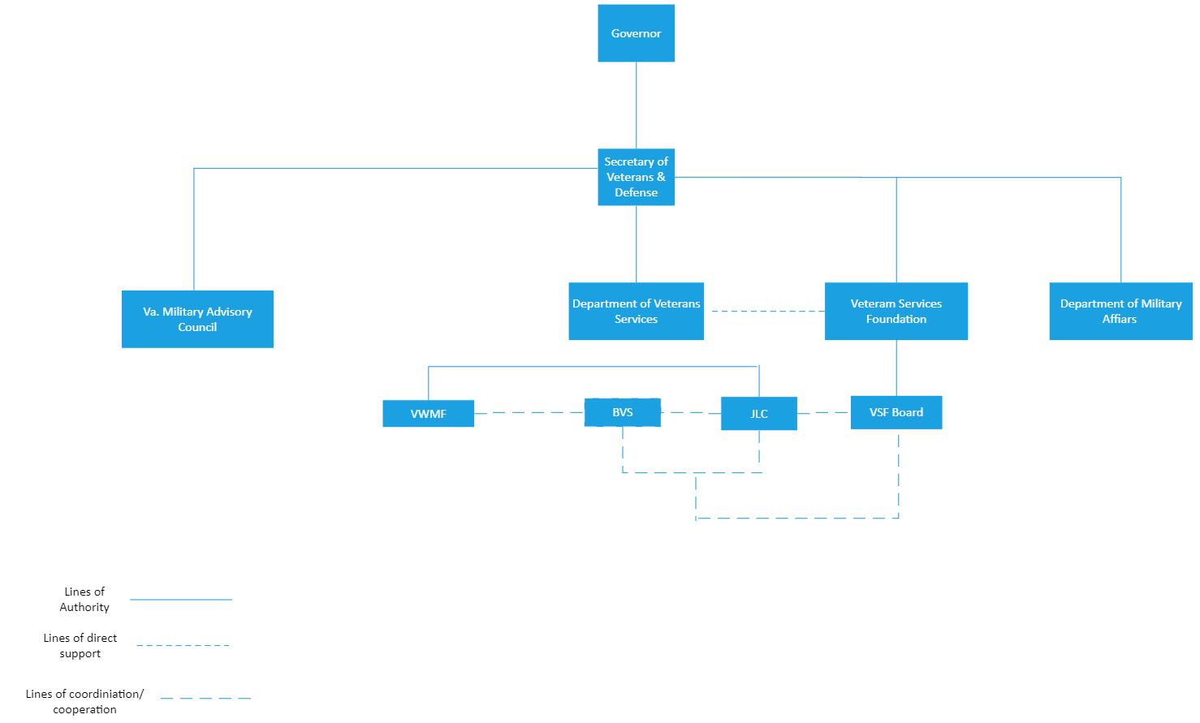

Appendix B

COMMONWEALTH of VIRGINIA
Department of Veterans Services and
Veterans Services Foundation Board of Trustees

MEMORANDUM OF UNDERSTANDING

This Memorandum of Understanding (MOU) is between the Department of Veterans Services (DVS) and the Veterans Services Foundation (VSF) that augments the provisions of the Code of Virginia §2.2- 2000 et seq., §2.2-2715 et seq., and the Appropriation Act with both agencies functioning as partners to provide for their shared mission to support Virginia's veterans and their families. This MOU recognizes that the DYS - VSF team must have clear and transparent communications and mutual understanding of requirements for resourcing programs and services in order to provide effective support to enable the expansion of support for the veteran community. Therefore:

- DYS and VSF shall participate in a united front to develop and fund programs that support Virginia veterans and their families; therefore, both agencies shall work together to:

  - Build relationships between VSF and DVS personnel, in general and on a functional and regional basis.
  - Conduct fundraising planning and execution to seek, promote, track, and stimulate contributions to support veterans' programs and services, and raise awareness about those programs and veterans issues across the Commonwealth, while targeting those veterans programs that can benefit most from VSF support.
  - Appoint staff members to monitor, coordinate, and expedite the terms and conditions of this MOU and act as agency agents for administration and act as liaison between DVS and VSF.
  - Keep each other informed of initiatives and activities, including those involving the executive and legislative branches of state government, which relate to our shared objective, and coordinate as appropriate.
  - Establish and maintain joint policies supporting administration of the Veterans Services Fund (the Fund), transfer of supplemental funding to DVS, VSF Funding Guidelines, fundraising, and other joint policies to facilitate the purposes of this MOU.
  - Pursue the goal to make Virginia the most veteran-friendly state in the nation.
d. Participate in a biennial review of this MOU and revise it as necessary.

- VSF raises funds and awareness in support of DVS programs and services across the Commonwealth and provides continuing support to DVS as follows:

  - Transfer funds to supplement funding for DVS programs and services in accordance with jointly agreed VSF Funding Guidelines, fund balances, and approved budgets.
  - Reimburse DVS for the Auditor of Public Accounts (APA) annual audits
(Code of Virginia§ 2.2-2717), unless APA waives the cost of VSF audits.

  - Reimburse DVS periodically on a mutually agreed upon basis for personnel costs incurred in supporting the VSF with administration, accounting, Fiscal Officer oversight, procurement, payroll, year-end financial reporting, DPB Budgeting/PB system entry, technical assistance, communications & public relations, marketing, human resources, and information technology. See attached Rider for details.

- DVS serves the veterans community and provides administrative and operational expertise to VSF in support of its fundraising and community awareness responsibilities as follows:

  - Furnish personnel and financial support, within DVS capabilities, to assist with VSF administration, accounting, technical assistance, public relations, marketing, and fundraising programs. VSF administration includes assisting with agendas, logistics (e.g., space for VSF meetings and staff members), transcription of minutes, and other necessary activities to support all VSF Board and Committee meetings and staff activities.
  - Provide substantive input on DVS and veteran population requirements and priorities to guide VSF fundraising.
  - Provide technical assistance regarding contracting initiatives and grants.

- This Memorandum of Understanding shall be reviewed periodically but not less than biennially.

This agreement amplifies requirements contained in the Code of Virginia, and as such, may be changed or eliminated as or when the Code of Virginia so directs.

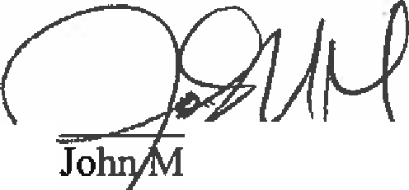
- , , , 10/21/2020

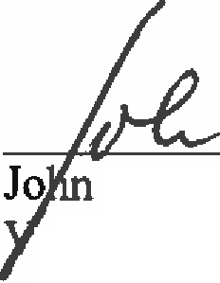
. Maxwell, Commissioner Department of Veterans Services

John D. Lesinski, Chairman, VSF

10/21/2020

Board of Trustees, as ratified by the Board on September 17, 2020

Annual Rider to DVS-VSF MOU
September 17, 2020

- The Memorandum of Understanding (MOU) between the Department of Veterans Services (DYS) and the Veterans Services Foundation (VSF) augments the provisions of the Code of Virginia §2.2-2000 et seq.,
§2.2-2715 et seq. This Rider to the MOU section 2.C supplements the Appropriation Act allotment of
$160,000.00 to VSF for services provided to the Foundation by DYS.

- This Rider is based on the premise that the DYS - VSF team must strive to maximize return on the allotment to resource services for effective mutual support. Both agencies recognize that the $160,000.00 is a reasonable amount for current required services and that the allotment is a set amount and will not increase with personnel and other services costs appropriated to agencies to cover increased expenditures placed upon the agency. The VSF Executive Director and the DYS Chief Financial Officer will review this amount periodically and at least annually to ensure it remains a reasonable amount.

- The allocation of funds for FY21 is set forth in the attachment (VSF to DYS General Fund Allocation for FY21) based on the following criteria:

  - The amounts allocated to personnel for their services are based on the hourly median salary for the position without fringe benefits, unless an individual is employed more than 72.5% of the time in VSF business.
  - The cost of equipment, supplies, and other support shall be based on a share of the charges incurred by DYS as assessed by other supporting state agencies (e.g., VITA, DGS, DOA) and state rates for travel and lodging.
  - The allocation of funds for mutual marketing, outreach, public relations, and fundraising is needed to raise awareness and VSF funds for DYS programs across the Commonwealth, while targeting those veterans programs that can benefit most from VSF support.

- VSF shall reimburse DYS semiannually in July and January in the amount of $70,000.00 for each six-month period and use the residual of$20,000.00 during May-June for reconciliation of costs.

- This Rider and the attached Annual Allocation of Funds shall be reviewed annually during the May-June period for the next fiscal year and approved by both VSF and DYS at the VSF June quarterly meeting.

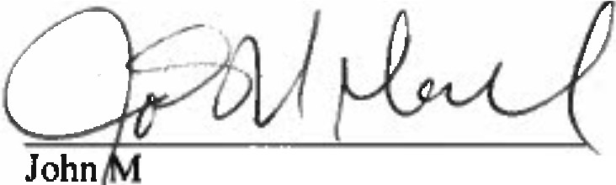
. Maxwell, Commissioner Department of Veterans Services
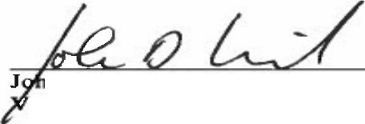

n
n D. Lesinski, Chairman eterans Services Foundation
10/21/2020
Date

10/21/2020

Board of Trustees, as ratified by the Board on September 17, 2020

